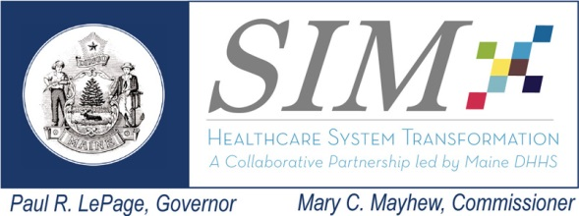  This work is made possible with funding from the Maine State Innovation Model Initiative | Subcommittee Meeting: Payment Reform  Date: October 21, 2014  Time: 3:00 to 5:00 pm  Location: MaineGeneral Medical Center, CR #2  Remote Access Information Follows Agenda
Meeting Goals: To provide status reports on SIM activities related to Cost of Care Work Group, PTE Behavioral Health, Community Health Worker; to discuss Risk 21 (care coordination); and, to Consider strategies to accelerate payment reform.
----- Agenda -----
Topics Lead Time
- Welcome and Introductions |  | Frank Johnson | 3:00 to 3:10
- Progress on Pathways to Excellence (PTE) measures |  | Patti Ross | 3:10 to 3:40
- Risk Statement 21 – Initiated by Delivery System Reform Subcommittee |  | Frank Johnson | 3:40 to 4:00
- Community Health Worker Initiative |  | Deb Wigand | 4:00 to 4:30
- Cost of Care Work Group and CEO Summit |  | Lisa Nolan | 4:30 to 4:50
- Public Comment |  | All | 4:50 to 5:00
Next Meeting:
December 16, 2014
3:00 to 5:00 pm

Dependencies Tracking (work from other subcommittees)
 |  | Data Infrastructure
Risk Tracking
Risk | Mitigation – Pro/Con |  | Owner | Escalate to SC?

1. Please join my meeting.
https://global.gotomeeting.com/meeting/join/139912405
2. Use your microphone and speakers (VoIP) - a headset is recommended. Or, call in using your telephone.
United States: +1 (213) 493-0606
Access Code: 139-912-405
Audio PIN: Shown after joining the meeting
Meeting ID:139-912-405

